Google Bar Group

By

Narjes Taqvaei

Mays Mansoor

Walaa Alani

Luan dinh

By

Narjes Taqvaei

Mays Mansoor

Walaa Alani

Luan dinh

Google Merchandise Store Analysis

Google Merchandise Store is:

Google Merchandise Store sells Google branded merchandise, which is an online retail store that any business owner refers to displaying products, promoting and selling  their product through google platform based website, and it’s a Traffic data includes information about where online **merchandise store** users originate and how they interact with the website. By analyzing traffic data, we can track traffic patterns and visitor behaviors to measure the **Google** Merch **store** website's effectiveness, combined with the overall digital presence.

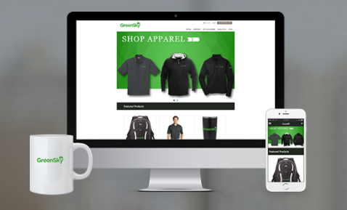

Google Analytic – Overview:

* Google Analytic is a free website analytics service that provides statistics and basis analytics tools for search engine optimization (SEO) and marketing purpose.
* Google Analytic contains:
  + Website traffic:
    - Where visitors came from & how
    - Which device and website platform did they use
    - Which products and promotion did you view
    - How many times did they visit
  + Track Conversions
    - Downloads
    - Page Views
    - Registrations
    - Shopping

The data come from:

The dataset provides 12 months (August 2016 to August 2017) of obfuscated Google Analytics 360 data from the [Google Merchandise Store](https://www.googlemerchandisestore.com/shop.axd/Home?utm_source=Partners&utm_medium=affiliate&utm_campaign=Data%20Share%20Promo) , a real ecommerce store that sells Google-branded merchandise, in BigQuery. It’s a great way analyze business data and learn the benefits of using BigQuery to analyze Analytics 360 data.

The data includes the data is typical of what an ecommerce website would see and includes the following information:

Traffic source data: information about where website visitors originate, including data about organic traffic, paid search traffic, and display traffic

Content data: information about the behavior of users on the site, such as URLs of pages that visitors look at, how they interact with content, etc.

Transactional data: information about the transactions on the Google Merchandise Store website.

Limitations: All users have view access to the dataset. This means you can query the dataset and generate reports but you cannot complete administrative tasks. Data for some fields is obfuscated such as fullVisitorId, or removed such as clientId, adWordsClickInfo and geoNetwork. This public dataset is hosted in Google BigQuery and is included in BigQuery's 1TB/mo of free tier processing. This means that each user receives 1TB of free BigQuery processing every month.

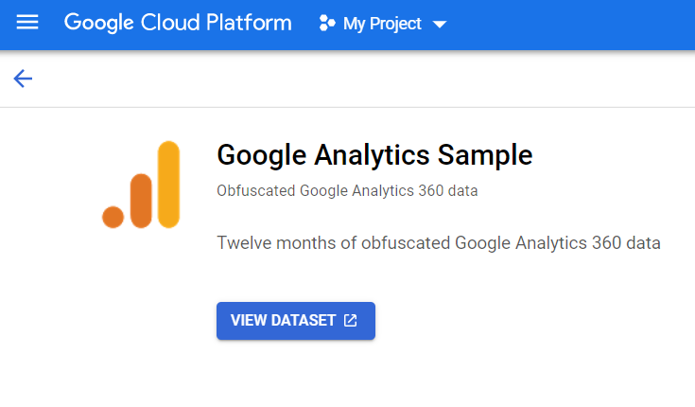

Dataset Source: <https://console.cloud.google.com/marketplace/product/obfuscated-ga360-data/obfuscated-ga360-data?filter=solution-type:dataset&q=analytics&project=metal-segment-300508&login=true&ref=https:%2F%2Fconsole.cloud.google.com%2Fmarketplace%2Fproduct%2Fobfuscated-ga360-data%2Fobfuscated-ga360-data>

Visitors:

* Which devices do visitors use the most?
  + Desktop
  + Phone
  + Tablet
* Which internet websites do visitors usually use?
  + Google Chrome
  + Safari
  + Firefox
  + Internet Explorer

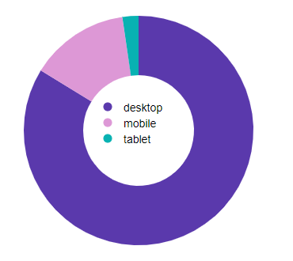

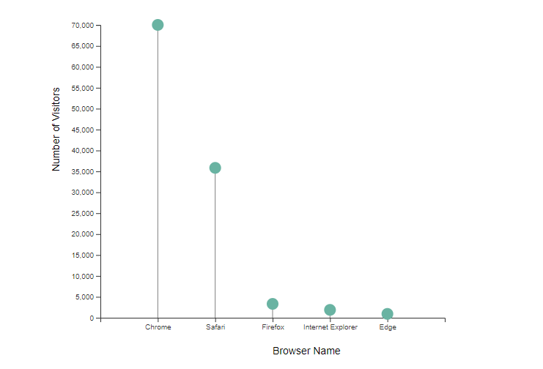

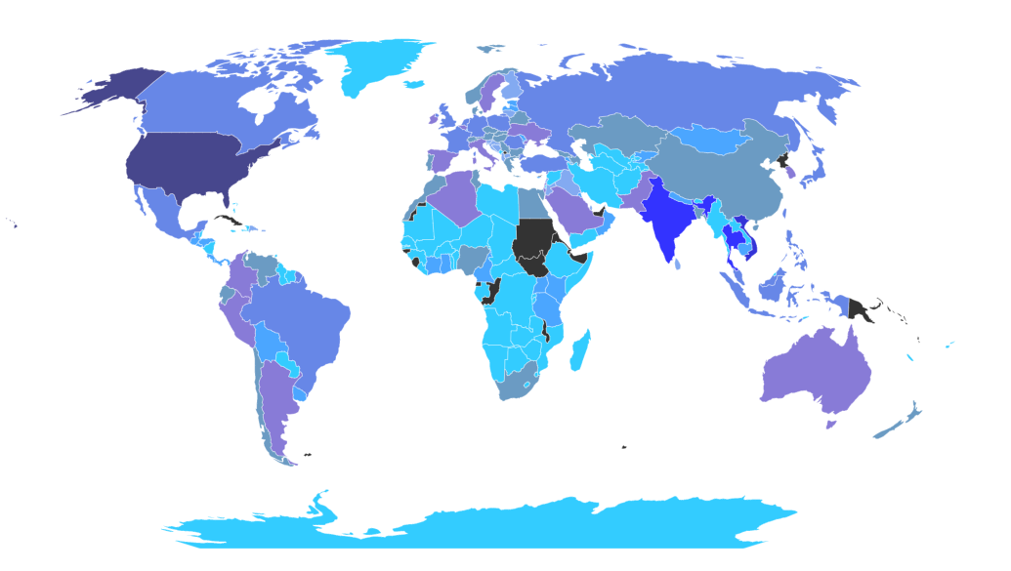

Technical team and marketing team should know from which device and browsers website is visited.

 Technical teams need to know this to make sure which platform is important to be error free and working with highest functionality. Website should work for both iOS and Android and main on main common browser. For example,  Only 21% of social media engagement is from a desktop and rest is from mobile mostly and less tablet. So, it is important to have a Mobile friendly website. If your web design is not browser compatible, there are chances that your potential customers may encounter incompatibility error messages as they surf through your website.

Marketing team need to use this info for the platforms they do advertise to attract more people to website. Advertisement prices is different for different platforms and marketing team using device statistics to make better and cheaper ads for engage more traffics.

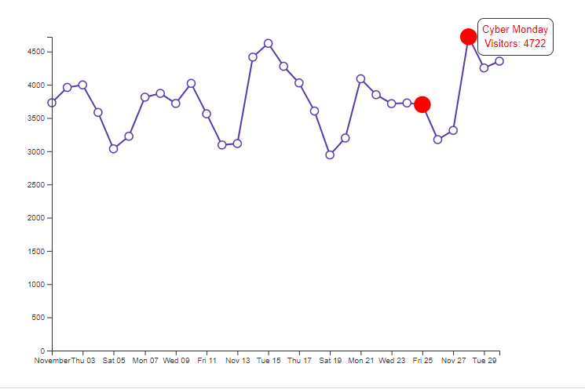

Within the month of November, customers visit the merchandise store more often due to a lot of promotions and offers of biggest sales event of year on black Friday.

The number of visitors to your website becomes the number of opportunities your business has at giving an impression, generating qualified leads, sharing your brand and building relationships.

By Increasing the quality of the website traffic and visits to your site, you are also increasing your conversion numbers which means better conversion rate. Number of visitors is important for both Technical team (SEO team) and marketing team (conversion rate is calculated as the number of goal conversions divided by the number of sessions, times 100).

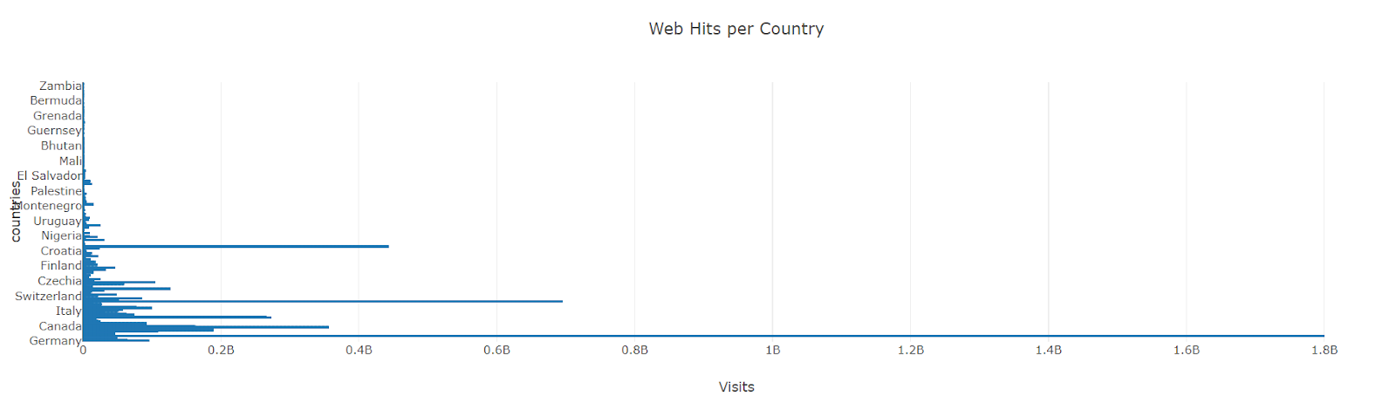

The most visitors come from:

*United State, England, France and China.*

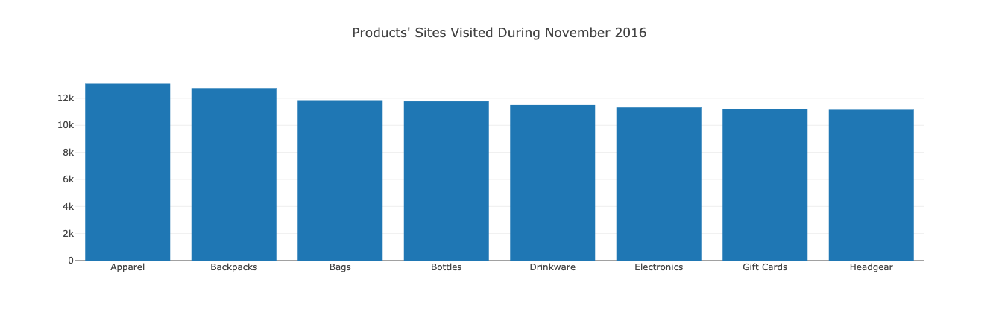

**TOP 8 Products**

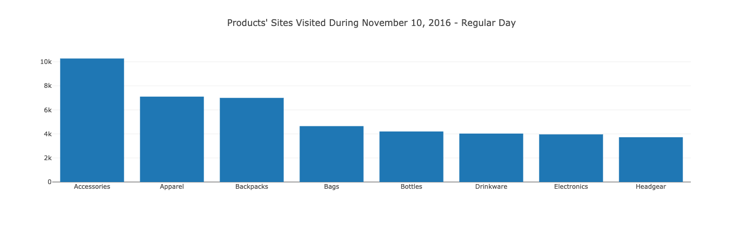

**TOP 8 Products - Black Friday**

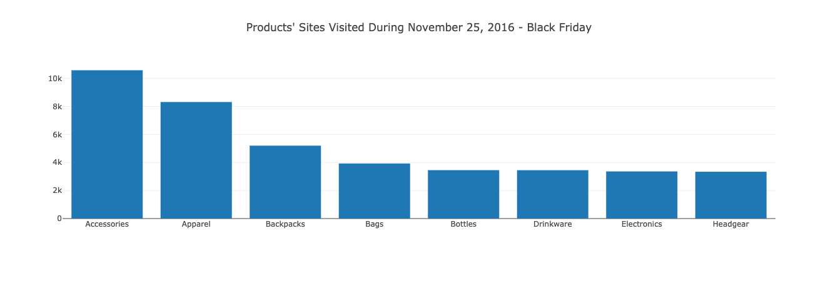

**TOP 8 Products - Cyber Monday**

**TOP 8 Products - Cyber Monday**

About the project

Our mission is to create a project with the purpose of showing how to show a google analytics data and how many visitors do we have thrown Nov 2016, black Friday and cyber Monday plus show from what devices are they coming from (Desktop, phone or tablet).

This valuable data we have could help data developers, big companies, online shop owners etc. to help to improve their business, we found our data from (console.cloud.google.com) and we download the csv file, share it on our GitHub repository and each student start to work on their part of data and start to clean it by using Jupyter Notebook .

We spent many hours working on the visualization and working through many challenges throw the way, Narjes come up with idea to show her data by using donate chart Mays and Walla showed their data by using bar charts and Luan to use a lollipop chart.

Narjes decided to use visitors and devices to show her data with donate chart, Walla viewed the products with visited by using bar chart to show all Nov Month, black Friday and cyber Monday, Luan showed the different between number of visitors and browser name.

At the end Narjes decided to add a different flavor to the project by creating a map with points would be a great way to visualize number of visitors for whole November and separately for Black Friday as well. By hover over mouse on each country you can see numbers of unique visitors for the selected time range from drop down menu. As it shows on map, most number of visitors are from USA both whole November and Black Friday.

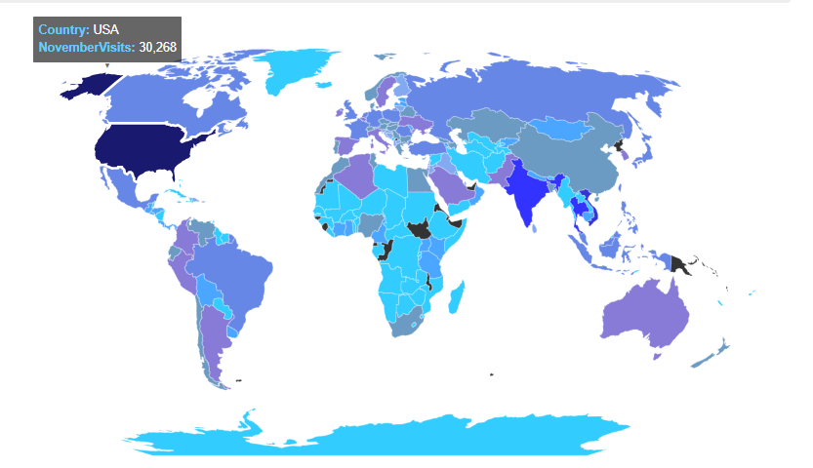

Despite all hard works from Luan and Narjes for make website live through Heroku, it didn’t work and we ended up using Github pages.

ei

Mays Mansoor

Walaa Alani

Luan d